

**Manav Rachna International Institute of Research and Studies**

**School of Computer Applications**

**Department of Computer Applications**

|  |  |
| --- | --- |
| **Submitted By** | |
| **Student Name** | **Abhinav Mishra** |
| **Roll No** | **24/SCA/BCA(AI&ML)/002** |
| **Programme** | **Bachelor of Computer Applications** |
| **Semester** | **1st** |
| **Section/Group** | **B** |
| **Department** | **Computer Applications** |
| **Session / Batch** | **2024-27** |
|  | |
| **Submitted To** | |
| **Faculty Name** | **Dr. Sakshi Gupta** |

|  |  |  |  |  |
| --- | --- | --- | --- | --- |
| **Index** | | | | |
| **S. No.** | **Program Date** | **Program** | **Signature/Date** | **Grade** |
| 1. |  | Create a simple html using basic tags. |  |  |
| 2. |  | Create web page that displays your name to the screen. |  |  |
| 3. |  | Create a web page and show the output from 1 to 10 in separate lines. |  |  |
| 4. |  | Create a web page and show the output from 1 to 10 in separate lines, each number being in different color. |  |  |
| 5. |  | How do I make a picture as a background on my web pages? |  |  |
| 6. |  | Create a web page to print a paragraph with 4-5 sentences, each sentence shall have a different font. |  |  |
| 7. |  | Write HTML code to print a paragraph that is description of a book, it shall include the title of the book, its author name; name and title should be underlined and all adjectives shall be bold and Italics. |  |  |
| 8. |  | Write HTML code to print your name using Heading tag, every letter shall be of different heading size. |  |  |
| 9. |  | Write HTML code to print the sequence of numbers 1-20. Each number shall be in different line with number 2 next to it as subscript, an equal sign and the result. |  |  |
| 10. |  | Write HTML code to display an image with border of size with width 200, height 200 pixels, leaving Hspace and Vspace of your choice with image hanging in the right side on the screen |  |  |
| 11. |  | Write HTML code to create a web page with heading. The heading shall be displayed at the top-center of the page and the image shall be at the centre, just below the heading. |  |  |
| 12. |  | Write HTML code using Multimedia tags. |  |  |
| 13. |  | Create a Table using Rowspan and Colspan taking example of student Record. |  |  |
| 14 |  | Write HTML code using table tag <table> and cellpadding and cell spacing as its attributes. |  |  |
| 15 |  | Create unordered, ordered and definition Lists taking example of your subjects in MCA IST, IInd and IIIrd Semester. |  |  |
| 16 |  | Write HTML code using <frameset> and <frame> tag with all its attributes |  |  |
| 17 |  | Write HTML code to design a form in HTML using controls and buttons such as Textbox, Text area, password, submit button, browse button, drop-down menu |  |  |
| 18 |  | Write HTML code to design a Registration Form in HTML. |  |  |
| 19 |  | Write HTML code to design a student admission Form in HTML. |  |  |
| 20 |  | Create a proper home page of your own using any components and styles. |  |  |
| 21 |  | Write HTML code for including Local hyperlinking in a web page. |  |  |
| 22 |  | Write HTML code for including Inter hyperlinking in a web page. |  |  |
| 23 |  | Write HTML code for including External hyperlinking in a web page. |  |  |
| 24 |  | Write code to show External CSS with HTML code |  |  |
| 25 |  | Write code to show Internal CSS with HTML code. |  |  |
| 26 |  | Write code to show Inline CSS with HTML code. |  |  |
| 27 |  | Write a program to add two numbers using form in JavaScript. |  |  |
| 28 |  | Write a program in JavaScript to swap two images using on mouseover event. |  |  |
| 29 |  | Write a simple JavaScript program to sort an array |  |  |
| 30 |  | Write a JavaScript program to take as input three numbers from the user. Find the minimum and maximum of the three numbers. Print the following output in BOLD in the following format: |  |  |

Q1. create a html page using basic tags.

INPUT :- <html>

<head>

<title> my first html page </title>

</head>

<body>

<h1>"hello world"</h1>

</body>

</html>

OUTPUT:-

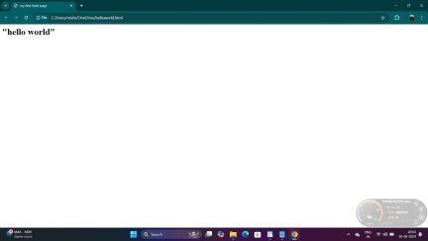Q2. create a page that displays your name to the screen.

INPUT- <HTML>

<head>

<title> my first html page </title>

</head>

<body>

<h1>"ABHINAV MISHRA"</h1>

</body>

</html>

OUTPUT

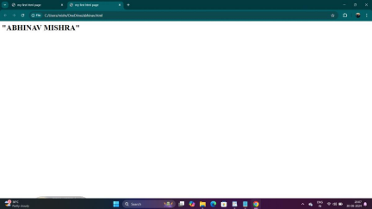

Q3. create a webpage and show the output from 1 to 10 in separate lines. INPUT- <html>

<head>

 <title>Numbers 1 to 10</title>

</head>

<body>

 1<br>

 2<br>

 3<br>

 4<br>

 5<br>

 6<br>

 7<br>

 8<br>

 9<br>

 10

</body>

</html>

OUTPUT

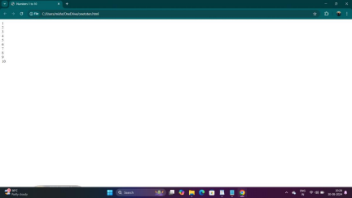

Q2.create a web page and show the output 1 to 10 in seperate lines,each number being in different  colour.

INPUT- <html >

<head>

 <title>Number Colors</title>

</head>

<body>

 <font color="red">1</font><br>

 <font color="orange">2</font><br>

 <font color="yellow">3</font><br>

 <font color="green">4</font><br>

 <font color="blue">5</font><br>

 <font color="indigo">6</font><br>

 <font color="violet">7</font><br>

 <font color="pink">8</font><br>

 <font color="brown">9</font><br>

 <font color="gray">10</font><br>

</body>

</html>

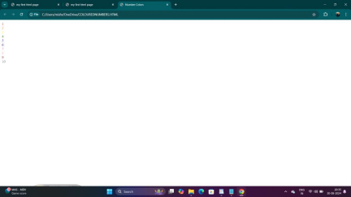Q5. how do i make a picture as a background on my pages?

INPUT- <html>

<head>

<title> background image </title>

</head>

</body>

<body

background="https://as2.ftcdn.net/v2/jpg/05/68/98/15/1000_F_568981524_2irG4VUSs06xbahAihTpku SfxKkw8FqX.jpg">

</body>

</html>

OUTPUT



Q6. create a web page to print a paragraph with 4-5 sentences ,each sentences shall have a different  font ?

INPUT- <HTML>

<head>

<title>paragraph with different fonts</title>

</head>

<body>

<h1>ABHINAV MISHRA</h1>

<p>

<B>my name is abhinav mishra.</B><br>

<I>i am studying at manav rachna institute of internationls reserch and studies pursuing bca ai ml it is  situated in faridabad,india</I><br>

<U>i am looking forward to become ai engineer and my course suits my goals perfectly </U><br> <B>my hobbies are doing editing in my free time and playing cricket on weekends</B></br> </p>

</body>

</html>

OUTPUT

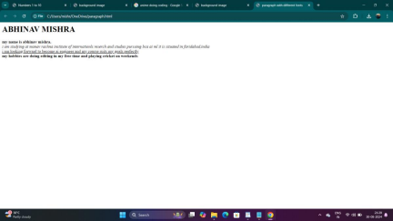

Q7. write a html code to print a paragraph that is a description book , it shall inclide the title of the  book ,its author name; name and title should be underlined and all adjectives shall be in bold italics

INPUT:- <html>

<head>

<title>Book Description</title>

</head>

<body>

<h1><u><B>The Great Gatsby</u></B></h1>

<p>AUTHOR NAME:<u>F.Scott Fitzgerald</u><br>

The Great Gatsby is a <B>classic novel</B> set in the <i>roaring</i> 1920s. It explores the  <B>glamorous</B> and <B>decadent</B> lifestyles of the era through the eyes of the  <i>mysterious</i >and wealthy Jay Gatsby. The story delves into themes of <B>unrequited love</B>,  moral decay, and the <i>elusive nature</i> of the American Dream.</p>

</body>

</html>

OUTPUT:-

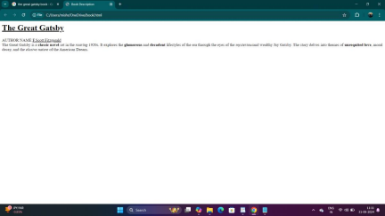Q8. write a html code to print name using heading tag , every letter shall be in different heading size  INPUT:- <html>

<head>

<title>Name in Different Heading Sizes</title>

</head>

<body>

<h1>A</h1>

<h2>b</h2>

<h3>h</h3>

<h4>i</h4>

<h5>n</h5>

<h6>a</h6>

<h1>v</h1>

<h2> </h2> <!-- Space between names -->

<h3>M</h3>

<h4>i</h4>

<h5>s</h5>

<h6>h</h6>

<h1>r</h1>

<h2>a</h2>

</body>

</html>

OUTPUT:-

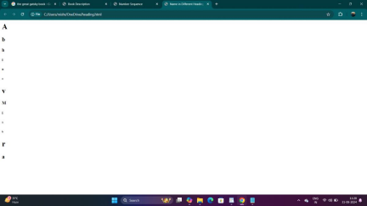

Q9. write html code to print the sequence of numbers 1-20. each number shall be in different line with  number 2 next to it as subscript , an eqal sign and the result.

INPUT- <html>

<head>

<title>Number Sequence</title>

</head>

<body>

<p>1<sub>2</sub> = 1</p>

<p>2<sub>2</sub> = 4</p>

<p>3<sub>2</sub> = 9</p> <p>4<sub>2</sub> = 16</p> <p>5<sub>2</sub> = 25</p> <p>6<sub>2</sub> = 36</p> <p>7<sub>2</sub> = 49</p> <p>8<sub>2</sub> = 64</p> <p>9<sub>2</sub> = 81</p>

<p>10<sub>2</sub> = 100</p> <p>11<sub>2</sub> = 121</p> <p>12<sub>2</sub> = 144</p> <p>13<sub>2</sub> = 169</p> <p>14<sub>2</sub> = 196</p> <p>15<sub>2</sub> = 225</p> <p>16<sub>2</sub> = 256</p> <p>17<sub>2</sub> = 289</p> <p>18<sub>2</sub> = 324</p> <p>19<sub>2</sub> = 361</p> <p>20<sub>2</sub> = 400</p> </body>

</html>

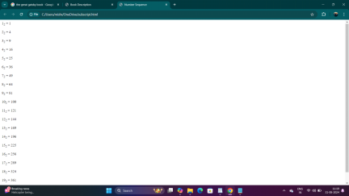

Q10. wtrite a html code to display an image with border of size with width 200 height 200 pixels ,  leaving Hspace and Vspace of your choice with image hanging in the right side on the screen.

INPUT:- <HTML>

<head>

<title>Image Display</title>

<style>

img {

border: 2px solid black;

width: 200px;

height: 200px;

display: block;

margin-left: auto;

margin-right: 0;

margin-top: 20px;

margin-bottom: 20px; }

</style>

</head>

<body>

<img src="https://m.media-amazon.com/images/I/81o8PrHjBqL._AC_UF1000,1000_QL80_.jpg"  alt="Sample Image">

</body>

</html>

OUTPUT :-

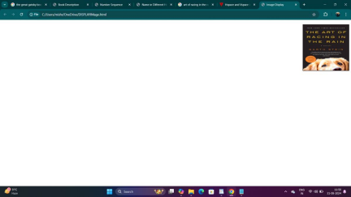

Q11. write a html code to create a web page with heading. the heading shall be displayed at the  top-centre of the page and the image shall be at the centre , just below the heading .

INPUT- <html>

<head>

<title>Centered Heading and Image</title>

<style>

body {

margin: 0;

font-family: Arial, sans-serif;

text-align: center;

justify-content: center;

align-items: center;

</style>

</head>

<body>

<h1>The Triumph of India 2024</h1>

<img src="https://www.financialexpress.com/wp-content/uploads/2024/06/T20-World-Cup-2024-1.jpg"  alt="T20 World Cup 2024">

</body>

</html>

OUTPUT-

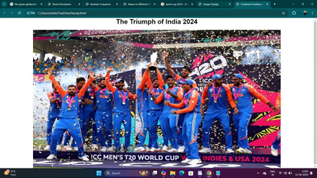

12. Write a HTML code using Multimedia tags

Input :- <!DOCTYPE html>

<html>

<head>

<title>Multimedia Example</title>

</head>

<body>

<h1>Multimedia Page</h1>

<h2>Image Example</h2>

<img src="C:\Users\mishr\Downloads\mountain-scenery-morning-sun-rays-4k-kf.jpg" width="300" height="200">

<h2>Audio Example</h2>

<audio controls width="300" height="30">

<source src="C:\Users\mishr\OneDrive\Documents\_storage_emulated_0_Android_data_com.fawazapp.blac.mp3">

</audio>

<h2>Video Example</h2>

<video width="300" height="200">

<source src="C:\Users\mishr\OneDrive\Documents\WhatsApp Video 2024-09-23 at 19.05.50_5ac523e4.mp4">

</video>

</body>

</html>

Output 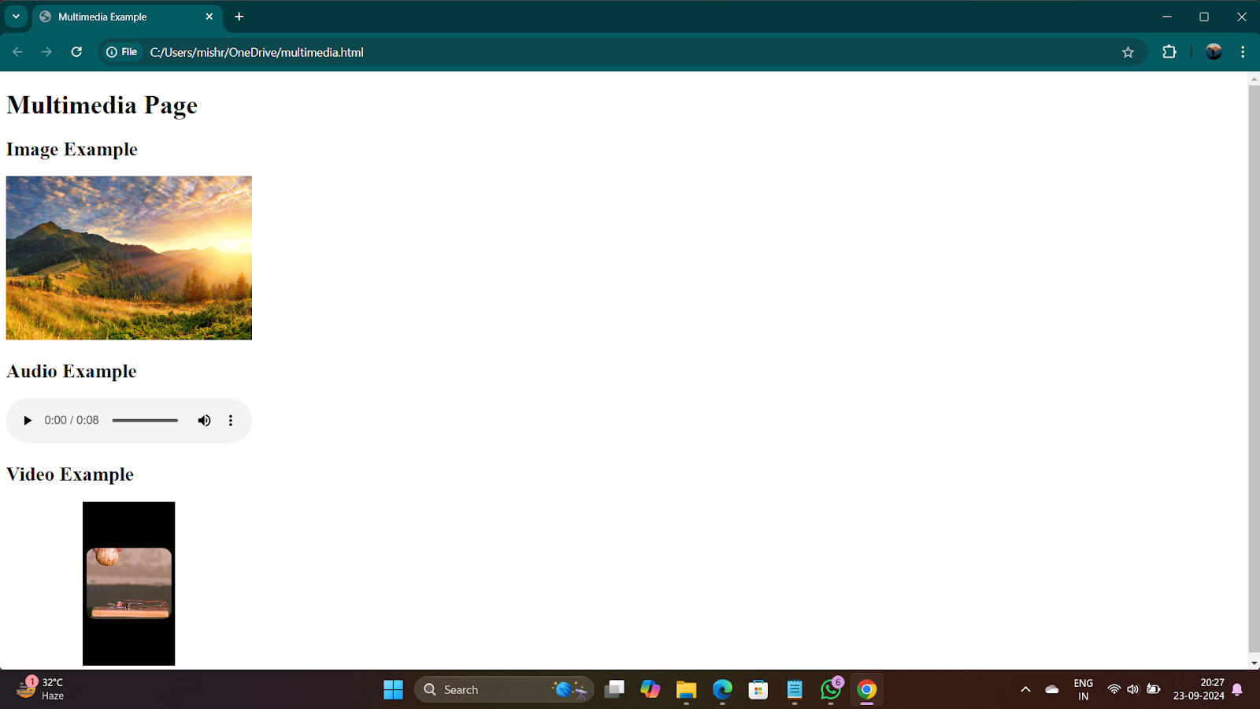

13. Create a Table Using Roswpan and Colspan taking example of student Record.

INPUT:- </html><!DOCTYPE html>

<html>

<head>

<title>Student Record</title>

</head>

<body>

<h2>Student Record</h2>

<table border="1">

<tr>

<th rowspan="2">ID</th>

<th rowspan="2">Name</th>

<th colspan="3">Marks</th>

</tr>

<tr>

<th>Maths</th>

<th>Science</th>

<th>English</th>

\</tr>

<tr>

<td>101</td>

<td>Abhinav</td>

<td>80</td>

<td>85</td>

<td>78</td>

</tr>

<td>102</td>

<tr>

<td>Priya</td>

<td>88</td>

<td>90</td>

<td>82</td>

</tr>

</table>

</body>

OUTPUT :-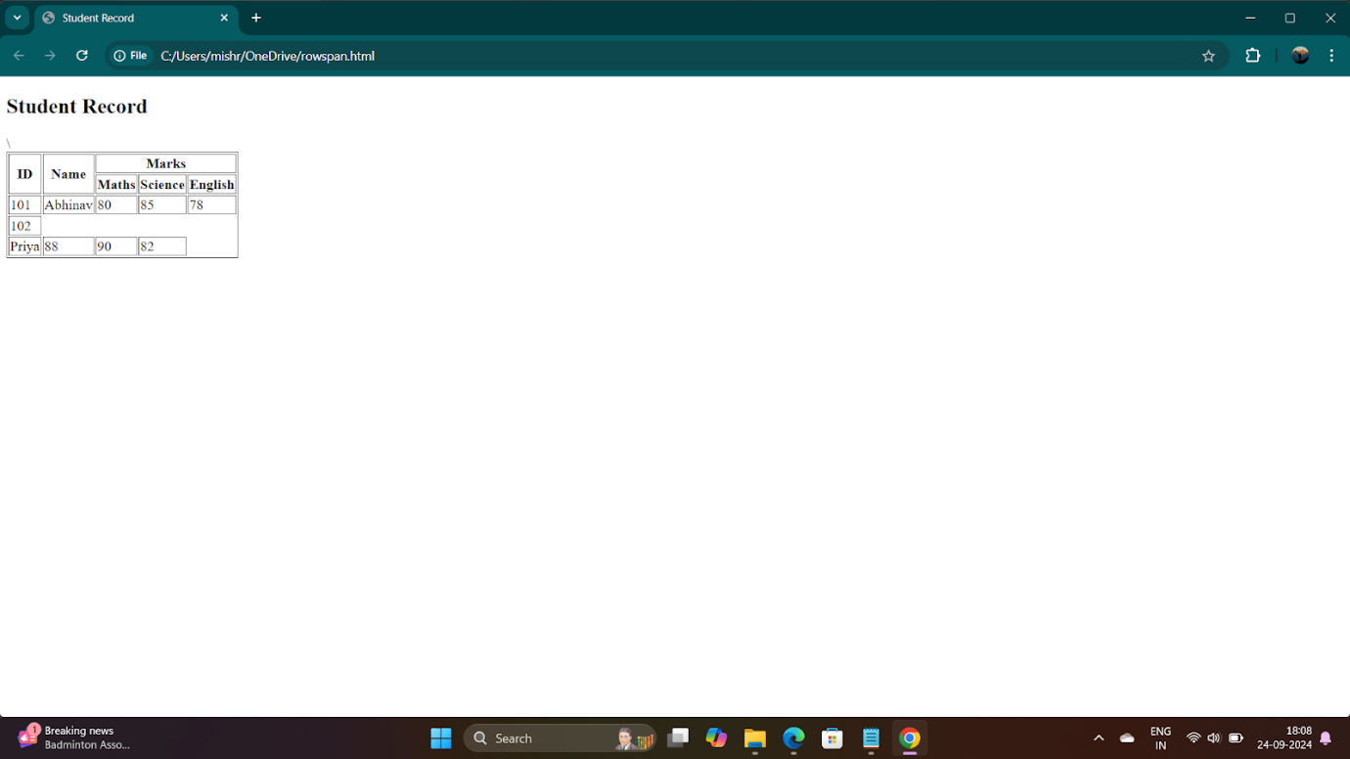

14. Write a HTML code using table tag <table> and cellpadding and cell spacing as its attributes.

INPUT:- <!DOCTYPE html>

<html>

<head>

<title>Simple Table with Cellpadding and Cellspacing</title>

</head>

<body>

<h2>Student Record</h2>

<table border="1" cellpadding="10" cellspacing="5">

<tr>

<th>ID</th>

<th>Name</th>

<th>Maths</th>

<th>Science</th>

<th>English</th>

</tr>

<tr>

<td>101</td>

<td>Abhinav</td>

<td>80</td>

<td>85</td>

<td>78</td>

</tr>

<tr>

<td>102</td>

<td>Priya</td>

<td>88</td>

<td>90</td>

<td>82</td>

</tr>

</table>

</body>

</html>

OUTPUT :- 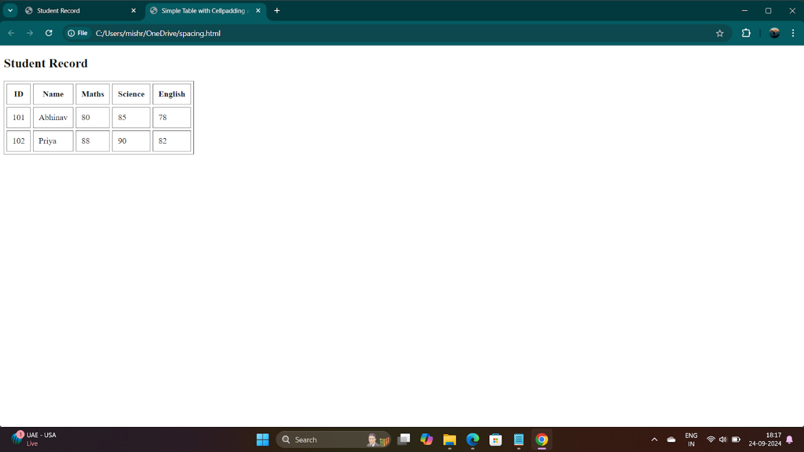

**15.**Create unoderede , ordered and definition lists taking example of your subjects in mca 1st 2nd and 3rd semester.

Input :- <!DOCTYPE html>

<html>

<head>

<title>MCA Subjects List</title>

</head>

<body>

<h1>MCA Subjects</h1>

<h2>1st Semester Subjects</h2>

<ul>

<li>Data Structures</li>

<li>Computer Networks</li>

<li>Operating Systems</li>

<li>Database Management Systems</li>

<li>Discrete Mathematics</li>

</ul>

<h2>2nd Semester Subjects</h2>

<ol>

<li>Software Engineering</li>

<li>Object-Oriented Programming</li>

<li>Web Technologies</li>

<li>Advanced DBMS</li>

<li>Computer Organization and Architecture</li>

</ol>

<h2>3rd Semester Subjects</h2>

<dl>

<dt>Machine Learning</dt>

<dd>Study of algorithms that improve automatically through experience.</dd>

<dt>Cloud Computing</dt>

<dd>Delivery of computing services over the cloud including storage and databases.</dd>

<dt>Artificial Intelligence</dt>

<dd>The simulation of human intelligence processes by machines, especially computer systems.</dd>

<dt>Big Data Analytics</dt>

<dd>Process of examining large data sets to uncover hidden patterns and insights.</dd>

<dt>Mobile Application Development</dt>

<dd>Creating software applications that run on mobile devices.</dd>

</dl>

</body>

</html>

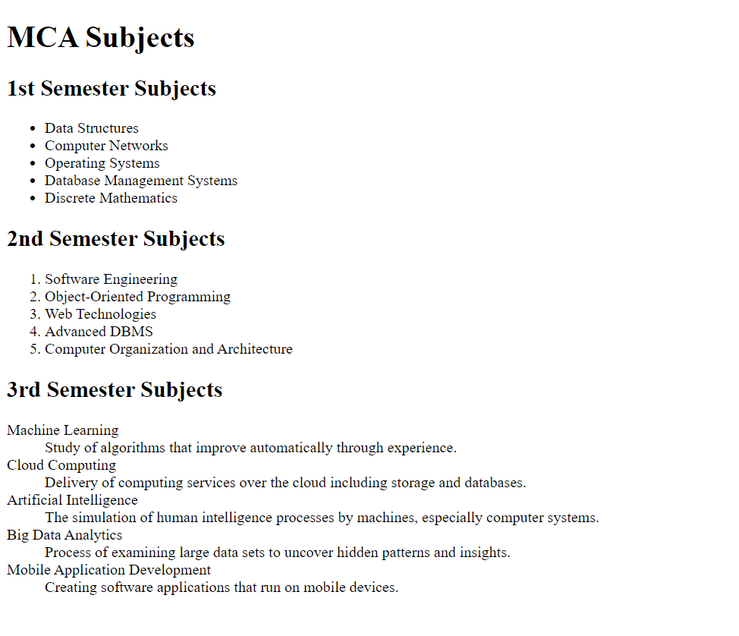

**16.**write htm code using <frameset> and <frame> tasg with all its attributes

<!DOCTYPE html>

<html>

<head>

<title>Simple Frameset Example</title>

</head>

<frameset cols="50%, 50%">

<frame src="https://www.bing.com/ck/a?!&&p=c30099040b0dcfd07b7ef28c6fde3b4d244cd66f5288debf7346f4be8089871aJmltdHM9MTcyODk1MDQwMA&ptn=3&ver=2&hsh=4&fclid=356028c1-bb60-6fed-36f0-3c23bafb6ef6&psq=fifa&u=a1aHR0cHM6Ly93d3cuZmlmYS5jb20v&ntb=1">

<frame src="https://www.bing.com/ck/a?!&&p=bbcd8a642eedbc6e713526b7da0db5ebcc0d1f4ef94f9ae68e3ad5cc07395b31JmltdHM9MTcyODk1MDQwMA&ptn=3&ver=2&hsh=4&fclid=356028c1-bb60-6fed-36f0-3c23bafb6ef6&psq=bcci&u=a1aHR0cHM6Ly93d3cuYmNjaS50di8&ntb=1">

</frameset>

<noframes>

<body>

<p>Your browser does not support frames. Please use a modern browser.</p>

</body>

</noframes>

</html>

Output :- 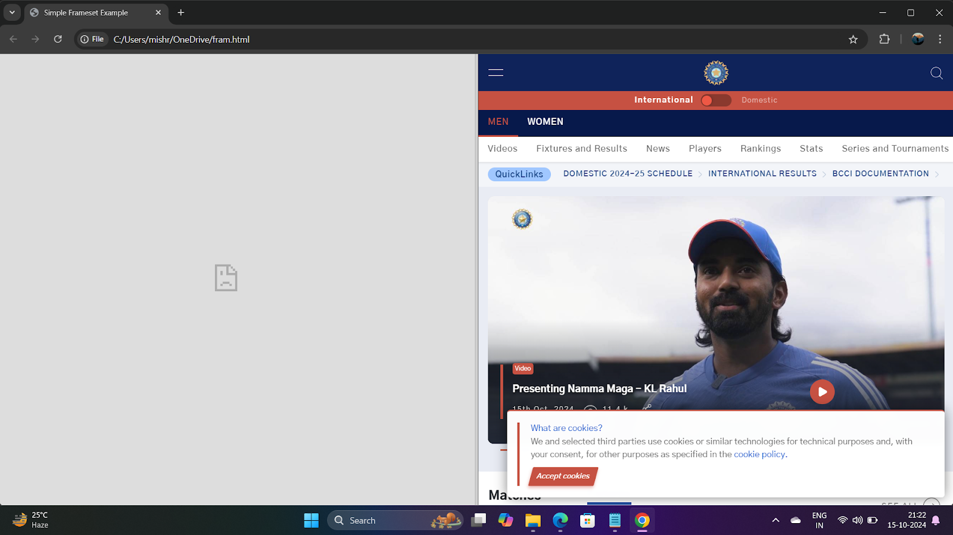

One side isnt showingboutput as website has refused to connect

**17.**Write HTML code to design a form in HTML using controls and buttons such as Teabox,Textarea,password, submit button, browse button , drop- down menu

Input :- <!DOCTYPE html>

<html>

<head>

<title>College Registration Form</title>

</head>

<body>

<h1>College Registration Form</h1>

<form >

<label for="name">Name:</label>

<input type="text" id="name" name="name" placeholder="Full name" required>

<br><br>

<label for="email">Email:</label>

<input type="email" id="email" name="email" placeholder="Email" required>

<br><br>

<label for="password">Password:</label>

<input type="password" id="password" name="password" placeholder="Password" required>

<br><br>

<label for="address">Address:</label>

<textarea id="address" name="address" rows="3" cols="30" placeholder="Enter your address"></textarea>

<br><br>

<label for="photo">Photo:</label>

<input type="file" id="photo" name="photo" accept="image/*">

<br><br>

<label for="course">Course:</label>

<select id="course" name="course">

<option value="bca">BCA</option>

<option value="mca">MCA</option>

<option value="btech">B.Tech</option>

</select>

<br><br>

<input type="submit" value="Register">

</form>

</body>

</html>

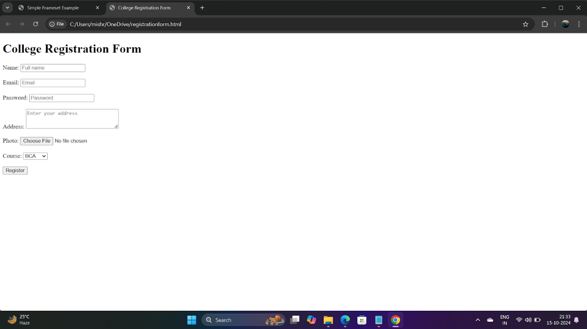

18. Write HTML code to design a Registration Form in HTML.

Input :- <!DOCTYPE html>

<htmlv>

<head>

<title>Cricket Academy Registration Form</title>

</head>

<body>

<h1>Cricket Academy Registration Form</h1>

<form action="#" method="post">

<label for="name">Name:</label>

<input type="text" id="name" name="name" placeholder="Full name" required>

<br><br>

<label for="age">Age:</label>

<input type="number" id="age" name="age" placeholder="Enter your age" required>

<br><br>

<label for="email">Email:</label>

<input type="email" id="email" name="email" placeholder="Email" required>

<br><br>

<label for="phone">Phone Number:</label>

<input type="tel" id="phone" name="phone" placeholder="Phone number" required>

<br><br>

<label for="skill">Skill Level:</label>

<select id="skill" name="skill">

<option value="beginner">Beginner</option>

<option value="intermediate">Intermediate</option>

<option value="advanced">Advanced</option>

</select>

<br><br>

<label for="comments">Additional Comments:</label>

<textarea id="comments" name="comments" rows="4" cols="30" placeholder="Any additional comments..."></textarea>

<br><br>

<input type="submit" value="Register">

</form>

</body>

</html>

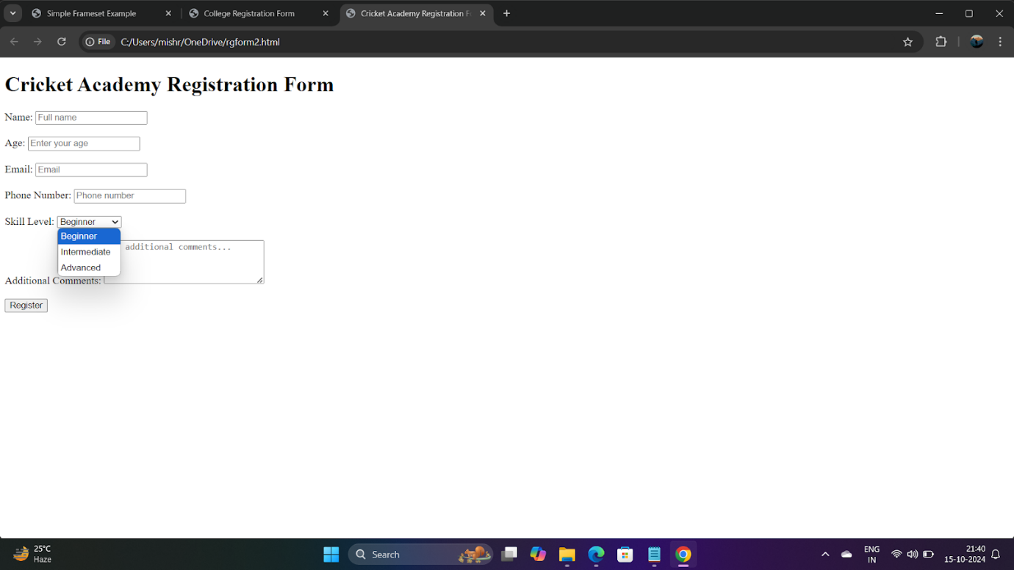

19. Write html code to design a student admission form in html.

Input :- <!DOCTYPE html>

<html>

<head>

<title>College Registration Form</title>

</head>

<body>

1<h1>College Registration Form</h1>

<form action="#" method="post" enctype="multipart/form-data">

<fieldset>

<legend>Personal Information</legend>

<label for="name">Full Name:</label>

<input type="text" id="name" name="name" required><br><br>

<label for="dob">Date of Birth:</label>

<input type="date" id="dob" name="dob" required><br><br>

<label for="gender">Gender:</label>

<input type="radio" id="male" name="gender" value="male">

<label for="male">Male</label>

<input type="radio" id="female" name="gender" value="female">

<label for="female">Female</label>

<input type="radio" id="other" name="gender" value="other">

<label for="other">Other</label><br><br>

</fieldset>

<fieldset>

<legend>Contact Details</legend>

<label for="email">Email:</label>

<input type="email" id="email" name="email" required><br><br>

<label for="phone">Phone Number:</label>

<input type="tel" id="phone" name="phone" required><br><br>

<label for="address">Address:</label>

<textarea id="address" name="address" rows="4" cols="40" required></textarea><br><br>

</fieldset>

<fieldset>

<legend>Academic Information</legend>

<label for="course">Select Course:</label>

<select id="course" name="course" required>

<option value="bca">BCA</option>

<option value="btech">B.Tech</option>

<option value="bsc">B.Sc</option>

<option value="mba">MBA</option>

</select><br><br>

<label for="year">Year of Study:</label>

<input type="number" id="year" name="year" min="1" max="4" required><br><br>

<label for="tenthMarks">10th Marks (%):</label>

<input type="number" id="tenthMarks" name="tenthMarks" min="0" max="100" step="0.01" required><br><br>

<label for="twelfthMarks">12th Marks (%):</label>

<input type="number" id="twelfthMarks" name="twelfthMarks" min="0" max="100" step="0.01" required><br><br>

</fieldset>

<fieldset>

<legend>Uploads</legend>

<label for="photo">Upload Photo:</label>

<input type="file" id="photo" name="photo" accept="image/*" required><br><br>

<label for="signature">Upload Signature:</label>

<input type="file" id="signature" name="signature" accept="image/*" required><br><br>

</fieldset>

<input type="submit" value="Register">

<input type="reset" value="Reset">

</form>

</body>

</html>

Output :- 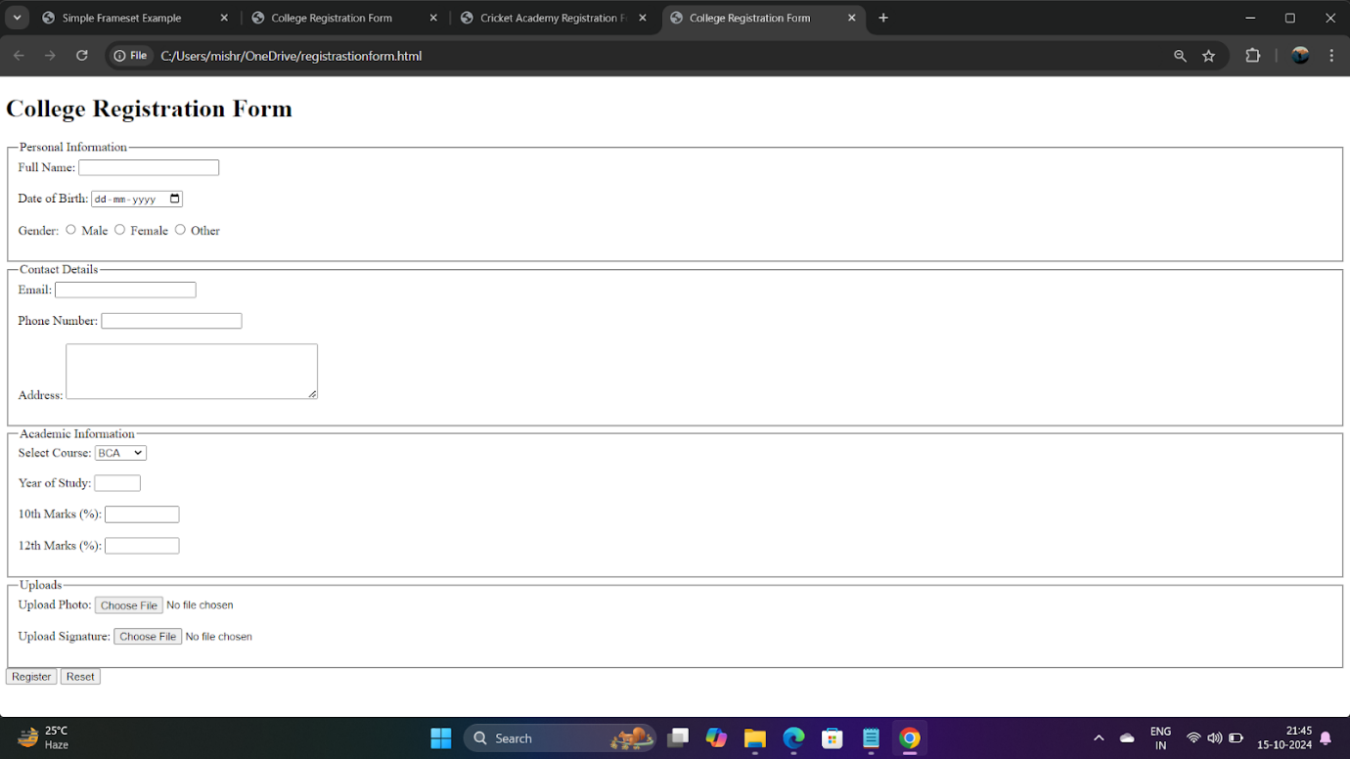

**20.**create a proper home page of your own using any components and styles

Input:- <!DOCTYPE html>

<html lang="en">

<head>

<title>Abhinav Mishra - BCA AI ML</title>

<style>

body {background-color: #f0f0f0; font-family: Arial, sans-serif; text-align: center;}

header {background-color: #4CAF50; color: white; border: 2px solid #388E3C;}

h1 {margin: 0; padding: 15px 0;}

section {background-color: #ffffff; margin: 20px auto; border: 2px solid #ddd; width: 80%;}

p {margin: 15px; color: #555;}

footer {background-color: #4CAF50; color: white; border-top: 2px solid #388E3C;}

.footer-text {margin: 10px 0;}

</style>

</head>

<body>

<header>

<h1>Welcome to Abhinav Mishra's Homepage</h1>

</header>

<section>

<h2>About Me</h2>

<p>Hello, I'm Abhinav Mishra, currently pursuing BCA in AI and ML at MRIIRS. I am interested in content creation, learning WEB DESIGNING AND DEO EDITING AS MY EXTRA SKILLS, and improving my coding skills.</p>

</section>

<section>

<h2>My Interests</h2>

<p>In my free time, I enjoy watching cricket, listening to music, and working on creative projects like making videos  my favorite players and some inspiring personalities that I follow are

 Virat Kohli, mr beast and cristiano ronaldo .</p>

</section>

<footer>

<div class="footer-text">Connect with me on my journey as a BCA student and aspiring content creator.</div>

</footer>

</body>

</html>

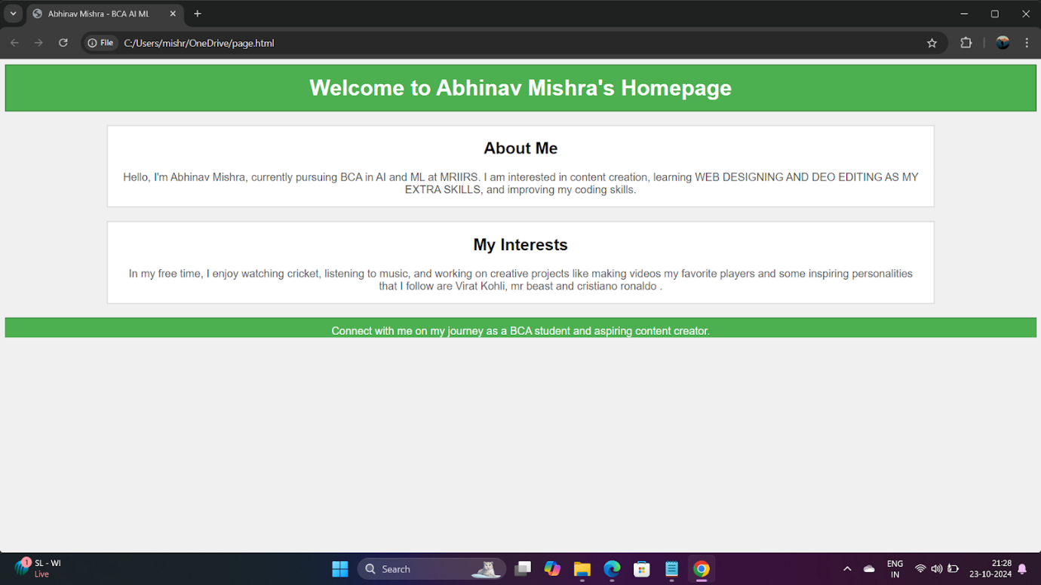

Q20. Create a proper home page of your own using any components and styles.

Input:

<!DOCTYPE html>

<html>

<head>

<title>My Personal Website</title>

<link rel="stylesheet" href="styles.css">

</head>

<body>

<header>

<h1>My Name</h1>

<nav>

<ul>

<li><a href="index.html">Home</a></li>

<li><a href="about.html">About</a></li>

<li><a href="projects.html">Projects</a></li>

<li><a href="contact.html">Contact</a></li>

</ul>

</nav>

</header>

<main>

<section>

<h2>Welcome to My

Website!</h2>

<p>This is a brief introduction about myself. Feel free to explore my projects and contact me.</p>

<img src="profile_pic.jpg" alt="Profile Picture">

</section>

</main>

<footer>

<p>&copy; 2023 My Name</p>

</footer>

</body>

</html>

Output:

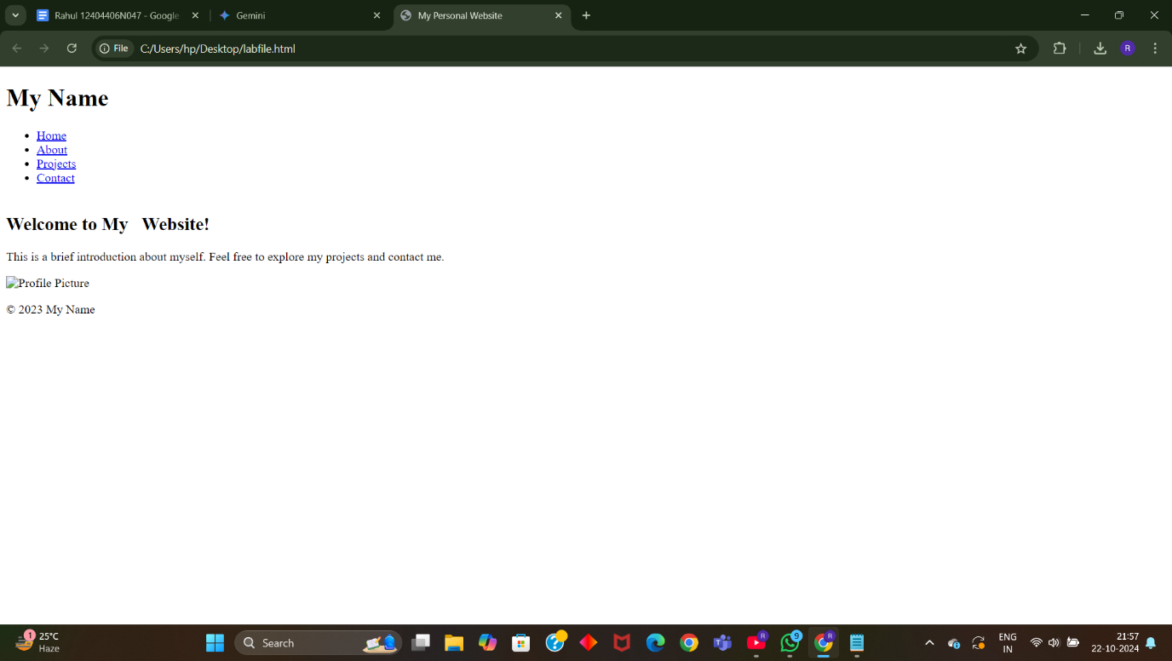

Q21. Write HTML code for including Local hyperlinking in a web page.

Input:

<!DOCTYPE html>

<html>

<head>

<title>Local Hyperlinking Example</title>

</head>

<body>

<h1>Local Hyperlinking</h1>

<p>This is a sample paragraph with a local hyperlink to another section within the same page.</p>

<a href="#section2">Jump to Section 2</a>

<h2 id="section2">Section 2</h2>

<p>This is the content of Section 2.</p>

</body>

</html>

Output:

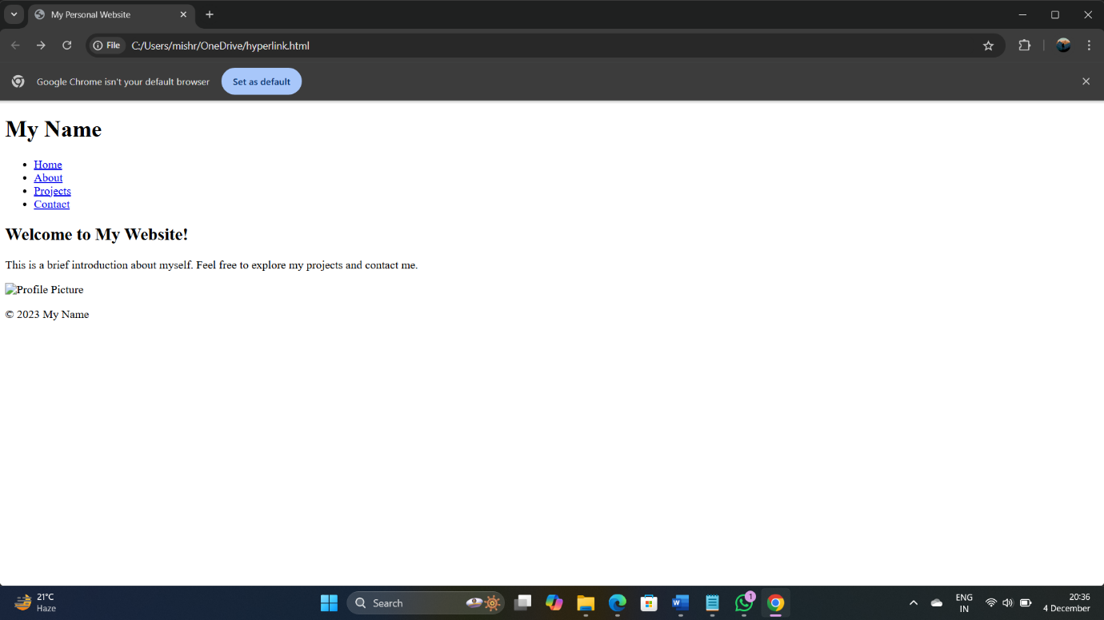

Q22. Write HTML code for including Inter hyperlinking in a web page.

Input:

<!DOCTYPE html>

<html>

<head>

<title>Inter Hyperlinking Example</title>

</head>

<body>

<h1>Inter Hyperlinking</h1>

<p>This is a sample paragraph with an inter-page hyperlink to another HTML file.</p>

<a href="page2.html">Go to Page 2</a>

</body>

</html>

Output:

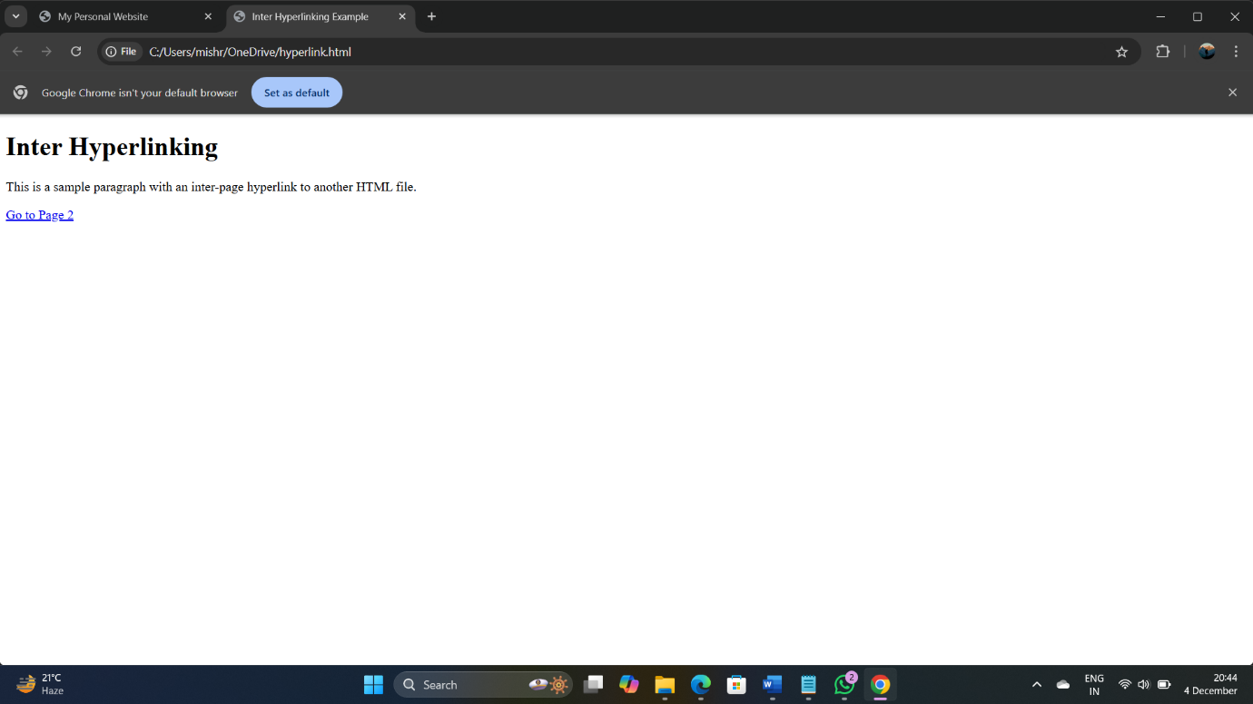

Q23. Write HTML code for including External hyperlinking in a web page.

Input:

<!DOCTYPE html>

<html>

<head>

<title>External Hyperlinking Example</title>

</head>

<body>

<h1>External Hyperlinking</h1>

<p>This is a sample paragraph with an external hyperlink to another website.</p>

<a href="https://www.example.com">Visit Example Website</a>

</body>

</html>

Output:

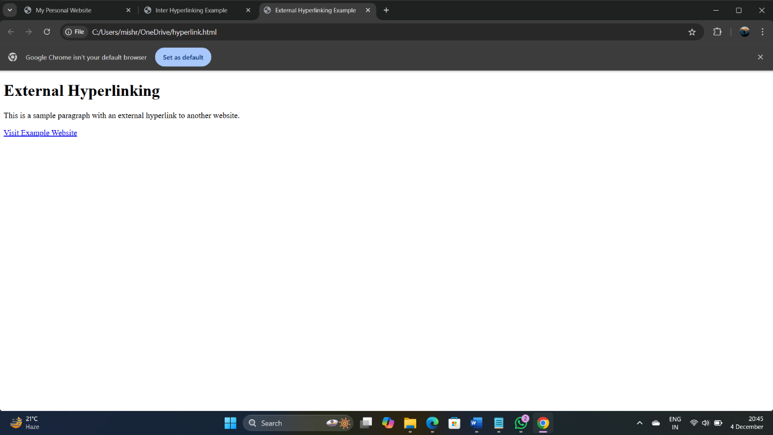

Q24. Write code to show External CSS with HTML code.

Input:

<!DOCTYPE html>

<html>

<head>

<title>External CSS Example</title>

<link rel="stylesheet" href="styles.css">

</head>

<body>

<h1>Hello, World!</h1>

<p>This is a paragraph styled with external CSS.</p>

</body>

</html>

Output:

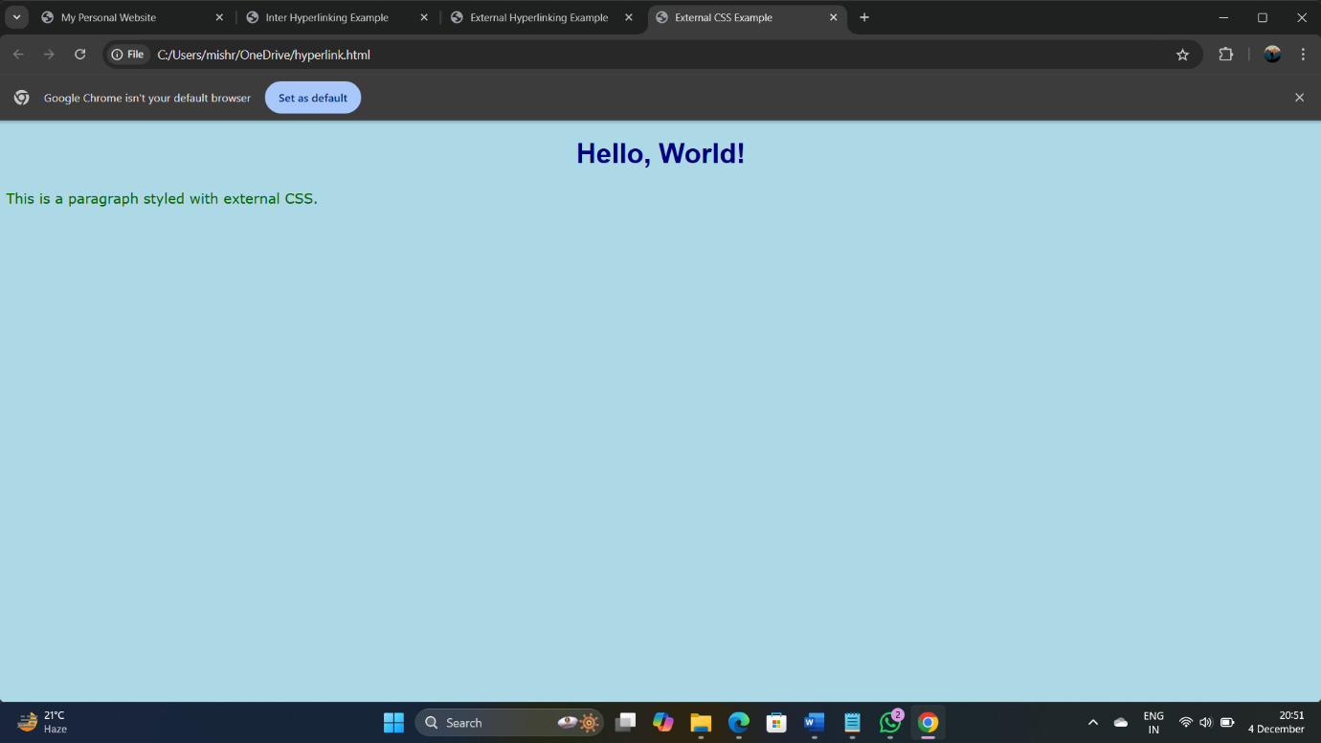

Q25. Write code to show Internal CSS with HTML code.

Input:

<!DOCTYPE html>

<html>

<head>

<title>Internal CSS Example</title>

</head>

<body>

<style>

body {

font-family: Arial, sans-serif;

background-color: lightblue;

}

h1 {

color: red;

text-align: center;

}

p {

color: green;

font-size: 18px;

}

</style>

<h1>Hello, World!</h1>

<p>This is a paragraph styled with internal CSS.</p>

</body>

</html>

Output:

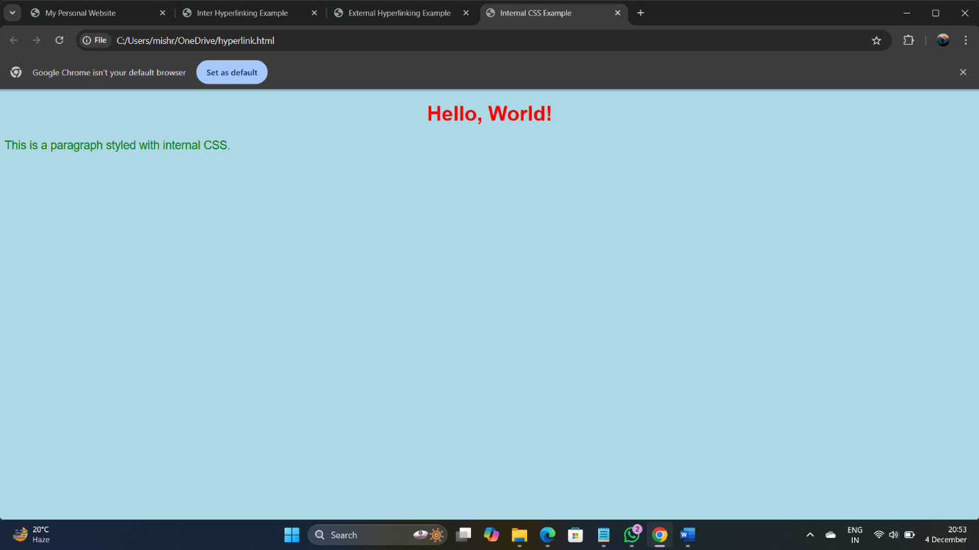

Q26. Write code to show Inline CSS with HTML code.

Input:

<!DOCTYPE html>

<html>

<head>

<title>Inline CSS Example</title>

</head>

<body>

<h1 style="color: red; text-align: center;">Hello, World!</h1>

<p style="color: green; font-size: 18px;">This is a paragraph styled with inline CSS.</p>

</body>

</html>

Output:

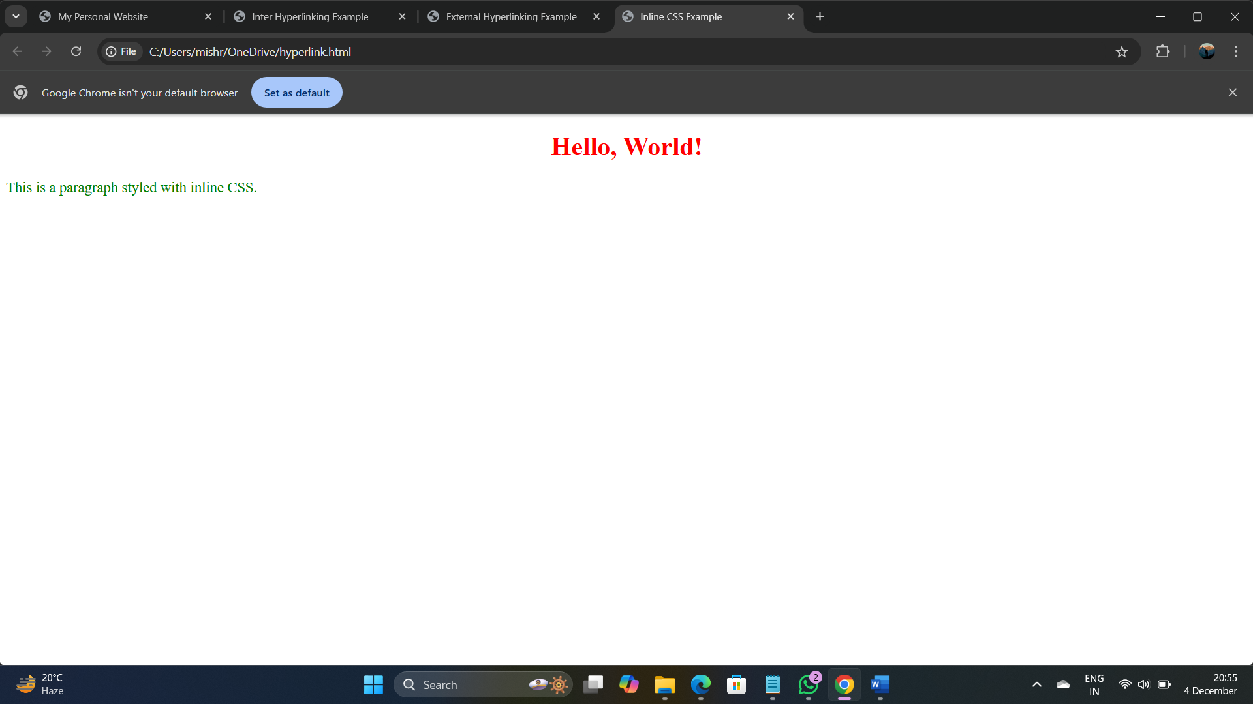

**Q27. Write a program to add two numbers using a form in JavaScript.**

**Input:**

<!DOCTYPE html>

<html>

<head>

<title>Add Two Numbers</title>

</head>

<body>

<h1>Add Two Numbers</h1>

<form>

<label for="num1">Enter Number 1:</label>

<input type="number" id="num1"><br><br>

<label for="num2">Enter Number 2:</label>

<input type="number" id="num2"><br><br>

<button type="button" onclick="addNumbers()">Calculate</button>

</form>

<p id="result"></p>

<script>

function addNumbers() {

let num1 = parseFloat(document.getElementById("num1").value);

let num2 = parseFloat(document.getElementById("num2").value);

document.getElementById("result").textContent = "Sum: " + (num1 + num2);

}

</script>

</body>

</html>

**Output:** 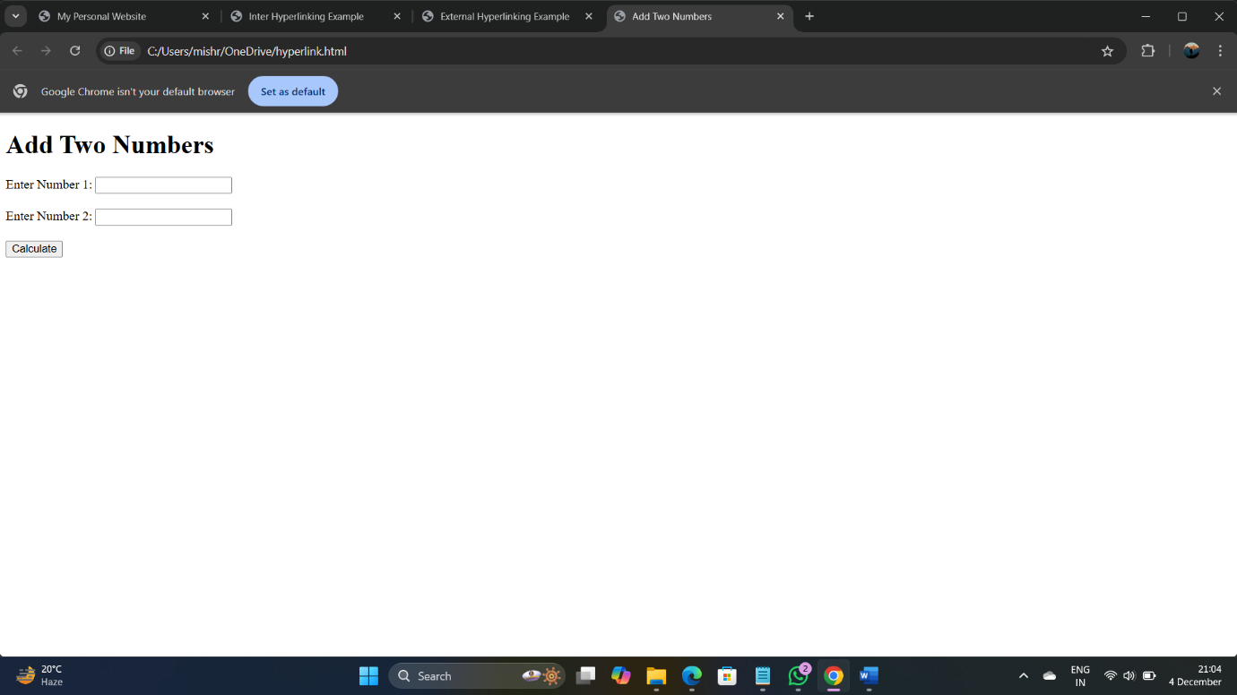

**Q28. Write a program in JavaScript to swap two images using the onmouseover event.**

**Input:**

<!DOCTYPE html>

<html>

<head>

<title>Swap Images</title>

</head>

<body>

<h1>Hover to Swap Images</h1>

<img id="image" src="image1.jpg" alt="First Image" width="300" height="200" onmouseover="swapImage()" onmouseout="restoreImage()">

<script>

function swapImage() {

document.getElementById("image").src = "image2.jpg";

}

function restoreImage() {

document.getElementById("image").src = "image1.jpg";

}

</script>

</body>

</html>

**Output:** 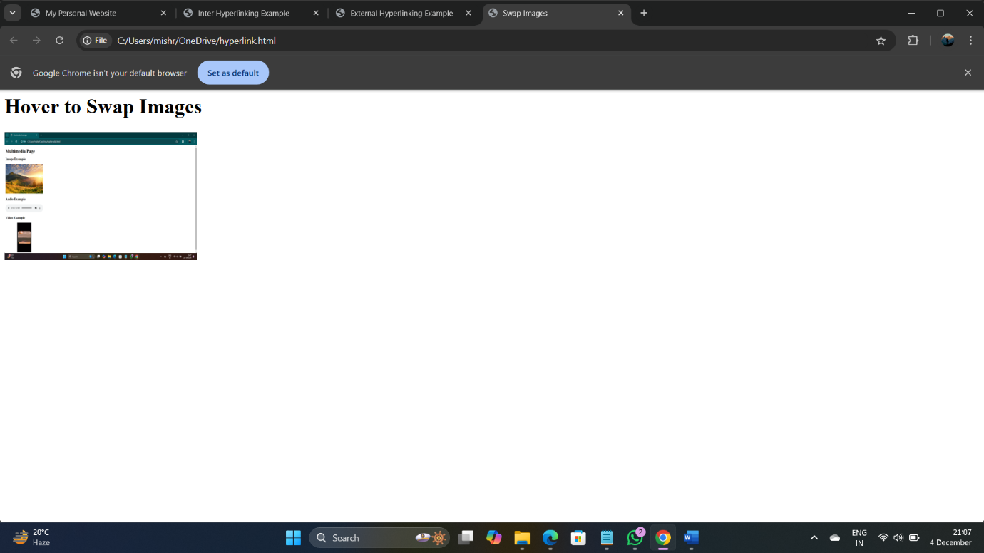

**Q29. Write a simple JavaScript program to sort an array.**

**Input:**

<!DOCTYPE html>

<html>

<head>

<title>Sort an Array</title>

</head>

<body>

<h1>Sort an Array</h1>

<script>

let numbers = [42, 8, 15, 23, 4];

document.write("Original Array: " + numbers + "<br>");

numbers.sort(function(a, b) { return a - b; });

document.write("Sorted Array: " + numbers);

</script>

</body>

</html>

**Output:** 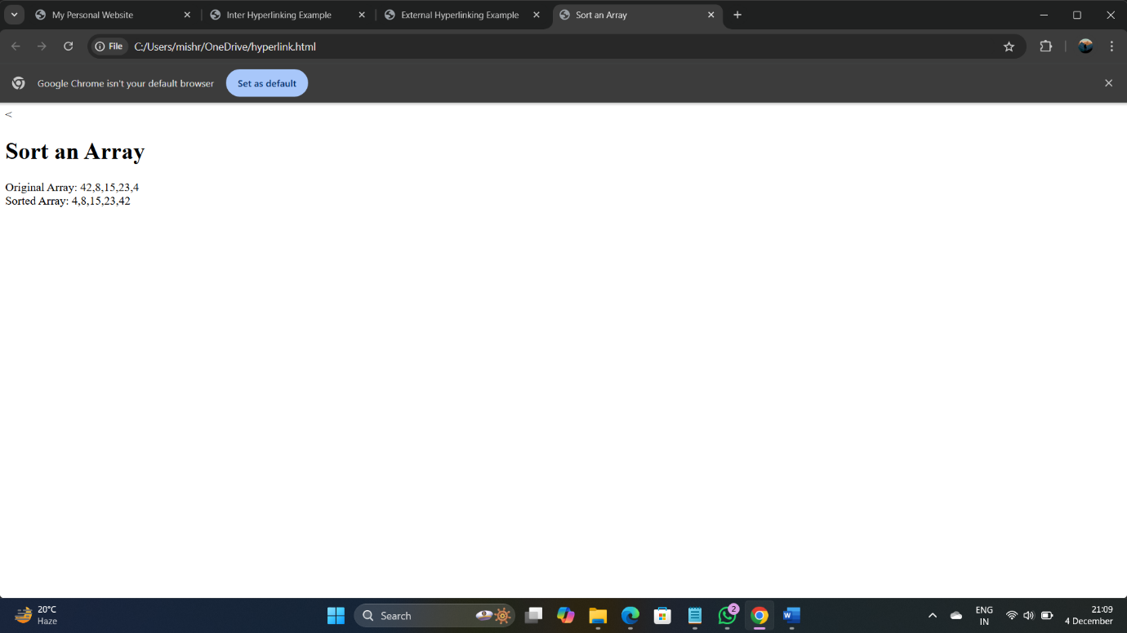

**Q30. Write a JavaScript program to take as input three numbers from the user. Find the minimum and maximum of the three numbers. Print the following output in BOLD in the specified format.**

**Input:**

<!DOCTYPE html>

<html>

<head>

<title>Find Min and Max</title>

</head>

<body>

<h1>Find Minimum and Maximum</h1>

<form>

<label for="num1">Enter Number 1:</label>

<input type="number" id="num1"><br><br>

<label for="num2">Enter Number 2:</label>

<input type="number" id="num2"><br><br>

<label for="num3">Enter Number 3:</label>

<input type="number" id="num3"><br><br>

<button type="button" onclick="findMinMax()">Find</button>

</form>

<p id="output"></p>

<script>

function findMinMax() {

let num1 = parseFloat(document.getElementById("num1").value);

let num2 = parseFloat(document.getElementById("num2").value);

let num3 = parseFloat(document.getElementById("num3").value);

let min = Math.min(num1, num2, num3);

let max = Math.max(num1, num2, num3);

document.getElementById("output").innerHTML = `<b>MINIMUM = ${min} MAXIMUM = ${max}</b>`;

}

</script>

</body>

</html>

